**PART – 01**

**Introduction**

**PART – 02**

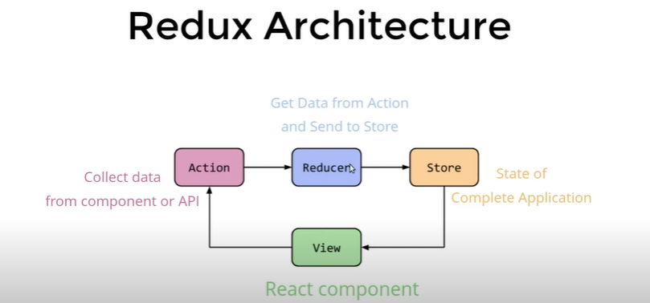

**PART – 03**

**Installation**

Create a new project by below command in vs code:

**npx create-react-app** reduxproject

where reduxproject is project name

goto inside project location by command and run below command;

**npm install redux**

goto inside project location by command and run below command;

**npm install react-redux**

**PART – 04**

**Props**

Create a new file **User.js** inside src folder and paste below code:

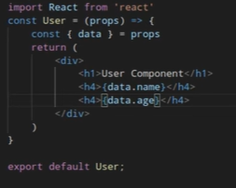

Open App.js file and paste below code:

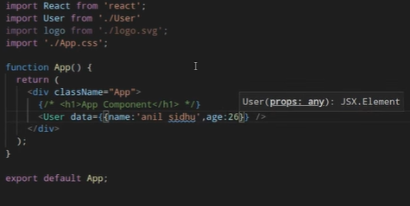

Check on browser.

**PART – 05**

**React-Redux Folder Structure**

Create a folder **components** inside src folder than create a file **Home.js** inside components folder.

Create another folder **containers** inside src folder than create a file **HomeContainer.js** inside containers folder.

Create another folder **service** inside src folder than create two folders **Actions** and **Reducers** inside Services folder than create a file **constants.js** inside Services folder than create a file **action.js** inside Actions folder, than create a file **reducer.js** inside Reducers folder than create a new file **index.js** inside Reducers folder

**PART – 06**

Open HomeContainer.js file inside containers folder and paste below code:



Open App.js file and replace below code:

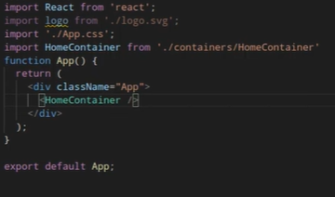

Open Home.js file inside components folder and paste below code:

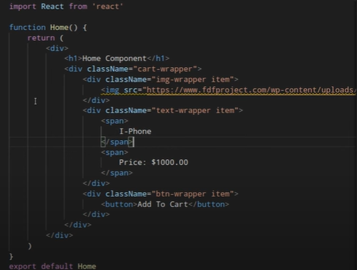

Add below code above <h1> tag:



And manage css part by self

**PART – 07**

**Actions**

Open actions.js file inside actions folder and paste below code:

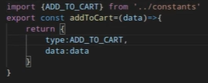

Open constants.js file inside service folder and paste below code:



**PART – 08**

**Reducer and root reducer**

Open actions.js file inside actions folder and paste below code:

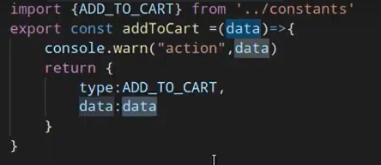

Open reducer.js file inside reducers folder and paste below code:

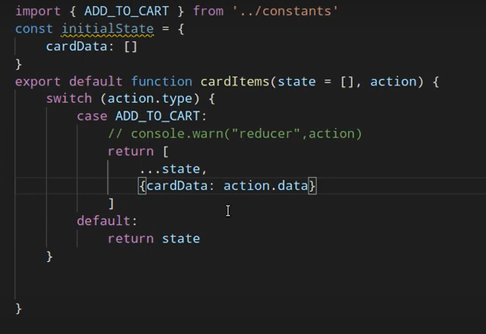

Open index.js file inside reducers folder and paste below code:

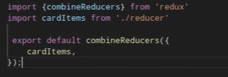

**PART – 09**

**container**

Open HomeContainer.js file inside containers folder and paste below code:

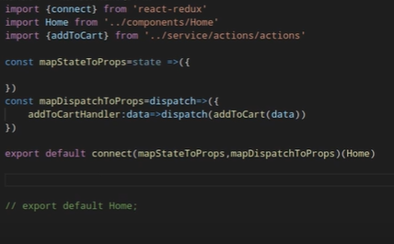

**PART – 10**

**Complete flow**

Open index.js file of root location and replace below code:

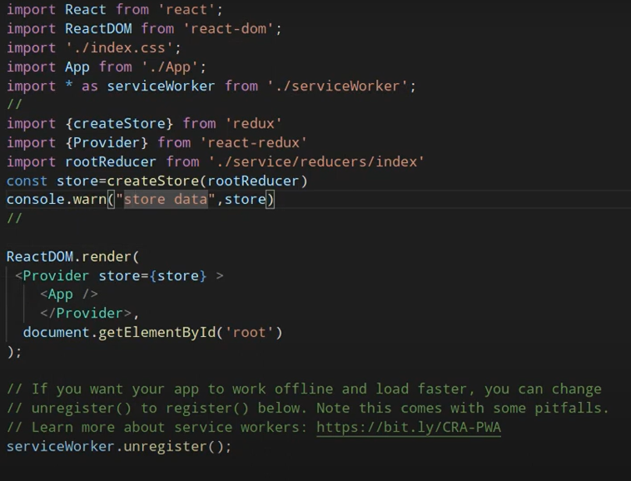

Open index.js file of reducers folder and replace below code:

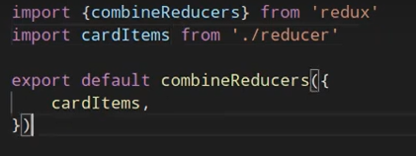

Open HomeContainer.js file of containers folder and replace below code:

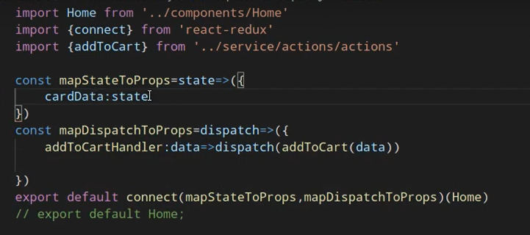

Open Home.js file of components folder and update button code:

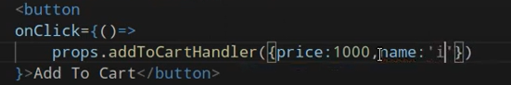

Than update below code:

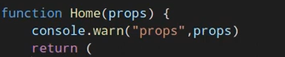

**PART – 11**

**Add item in cart**

Open HomeContainer.js file of containers folder and replace below code:

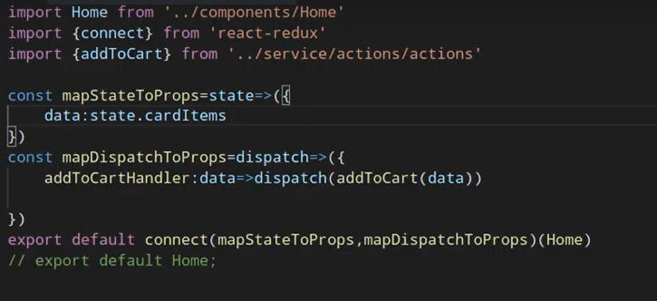

Open Home.js file of components folder and update below code:



Than update below code:

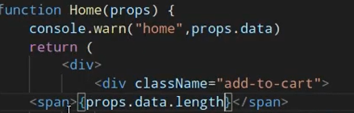

**PART – 12**

**Share data between components**

Create a new file **Header .js** inside components folder and paste below code:

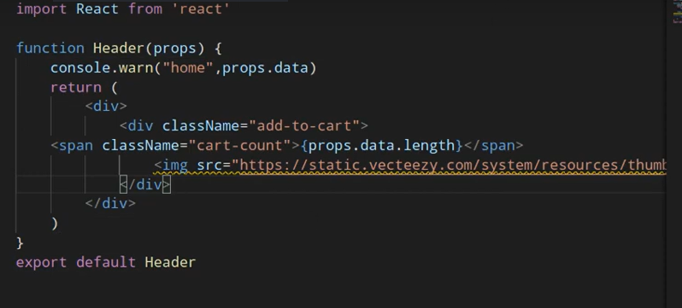

Open Home.js file of components folder and remove below code:

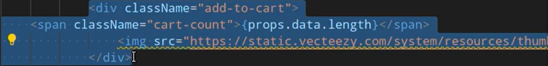

Create a new file **HeaderContainer.js** inside containers folder and paste below code;

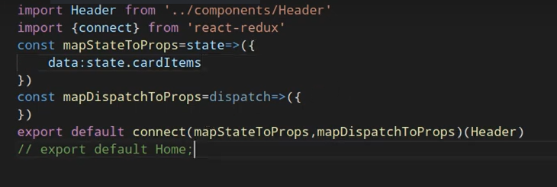

Open App.js file and replace below code:

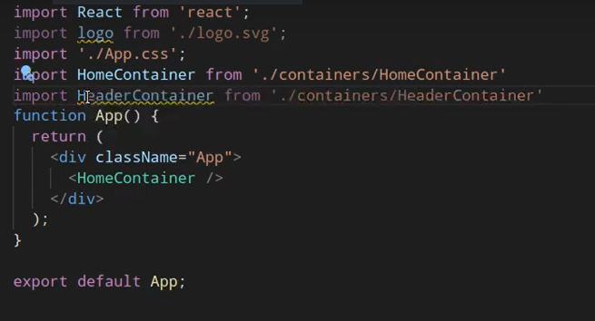

Than add below code before <HomeContainer /> :

<HeaderContainer />

**PART – 13**

**Remove item from cart**

Open actions.js file inside actions folder and replace below code:

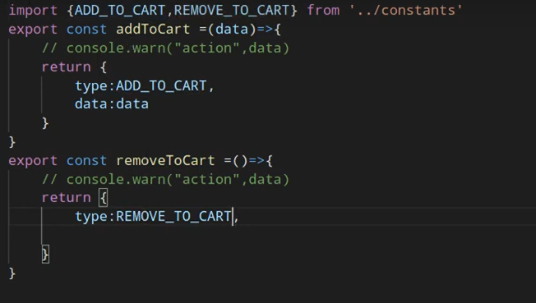

Open constants.js file inside service folder and replace below code:

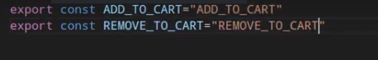

Open HomeContainer.js file of containers folder and replace below code:

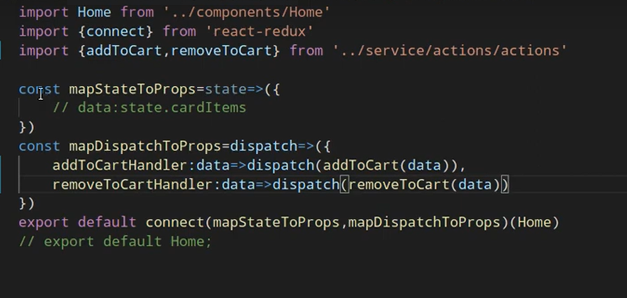

Open Home.js file of components folder and add below code after add to cart button:

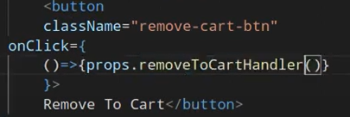

Open reducer.js file inside reducers folder and replace below code:

